

**Carrier 4.0HP Non-Inverter**

**Rs. 202,600/-**

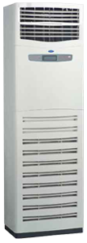

**Product Features**

* 24 hours timer
* Independent Dehumidification
* Low Noise Air Flow System
* Easy Clean Panel
* Remote Control Pocket

**Specification**

**Type** Wall Mounted Split AC

**Cooling (Btu/h)** 42000

**Voltage (V)** 220-240

**Power Input (W)** 3200

**EER (Btu/W-h-W/W)** 6.1-4.75